**SPCM LAB**

**EXPERIMENT - 11**

Step 1 -: Setup two EC2 Instances

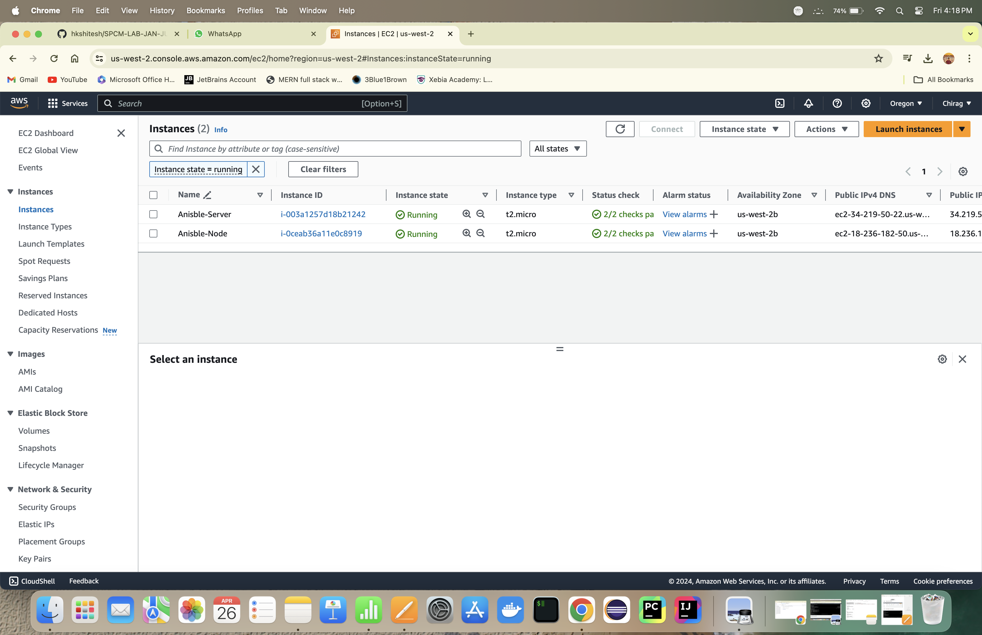

Step 2 -: Install Ansible on both Instances

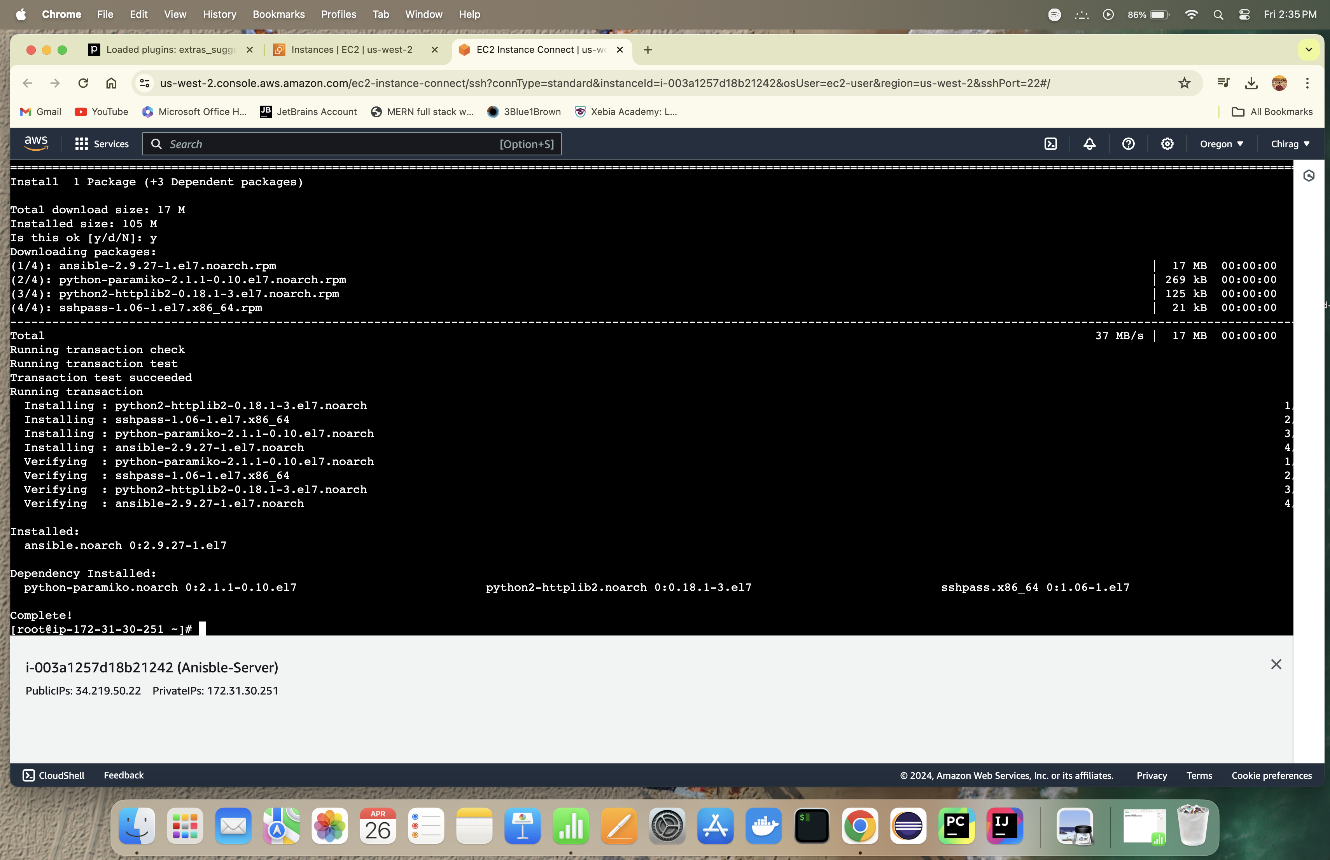

Step 3 -: Configure /etc/ansible/hosts file on ansible server instance

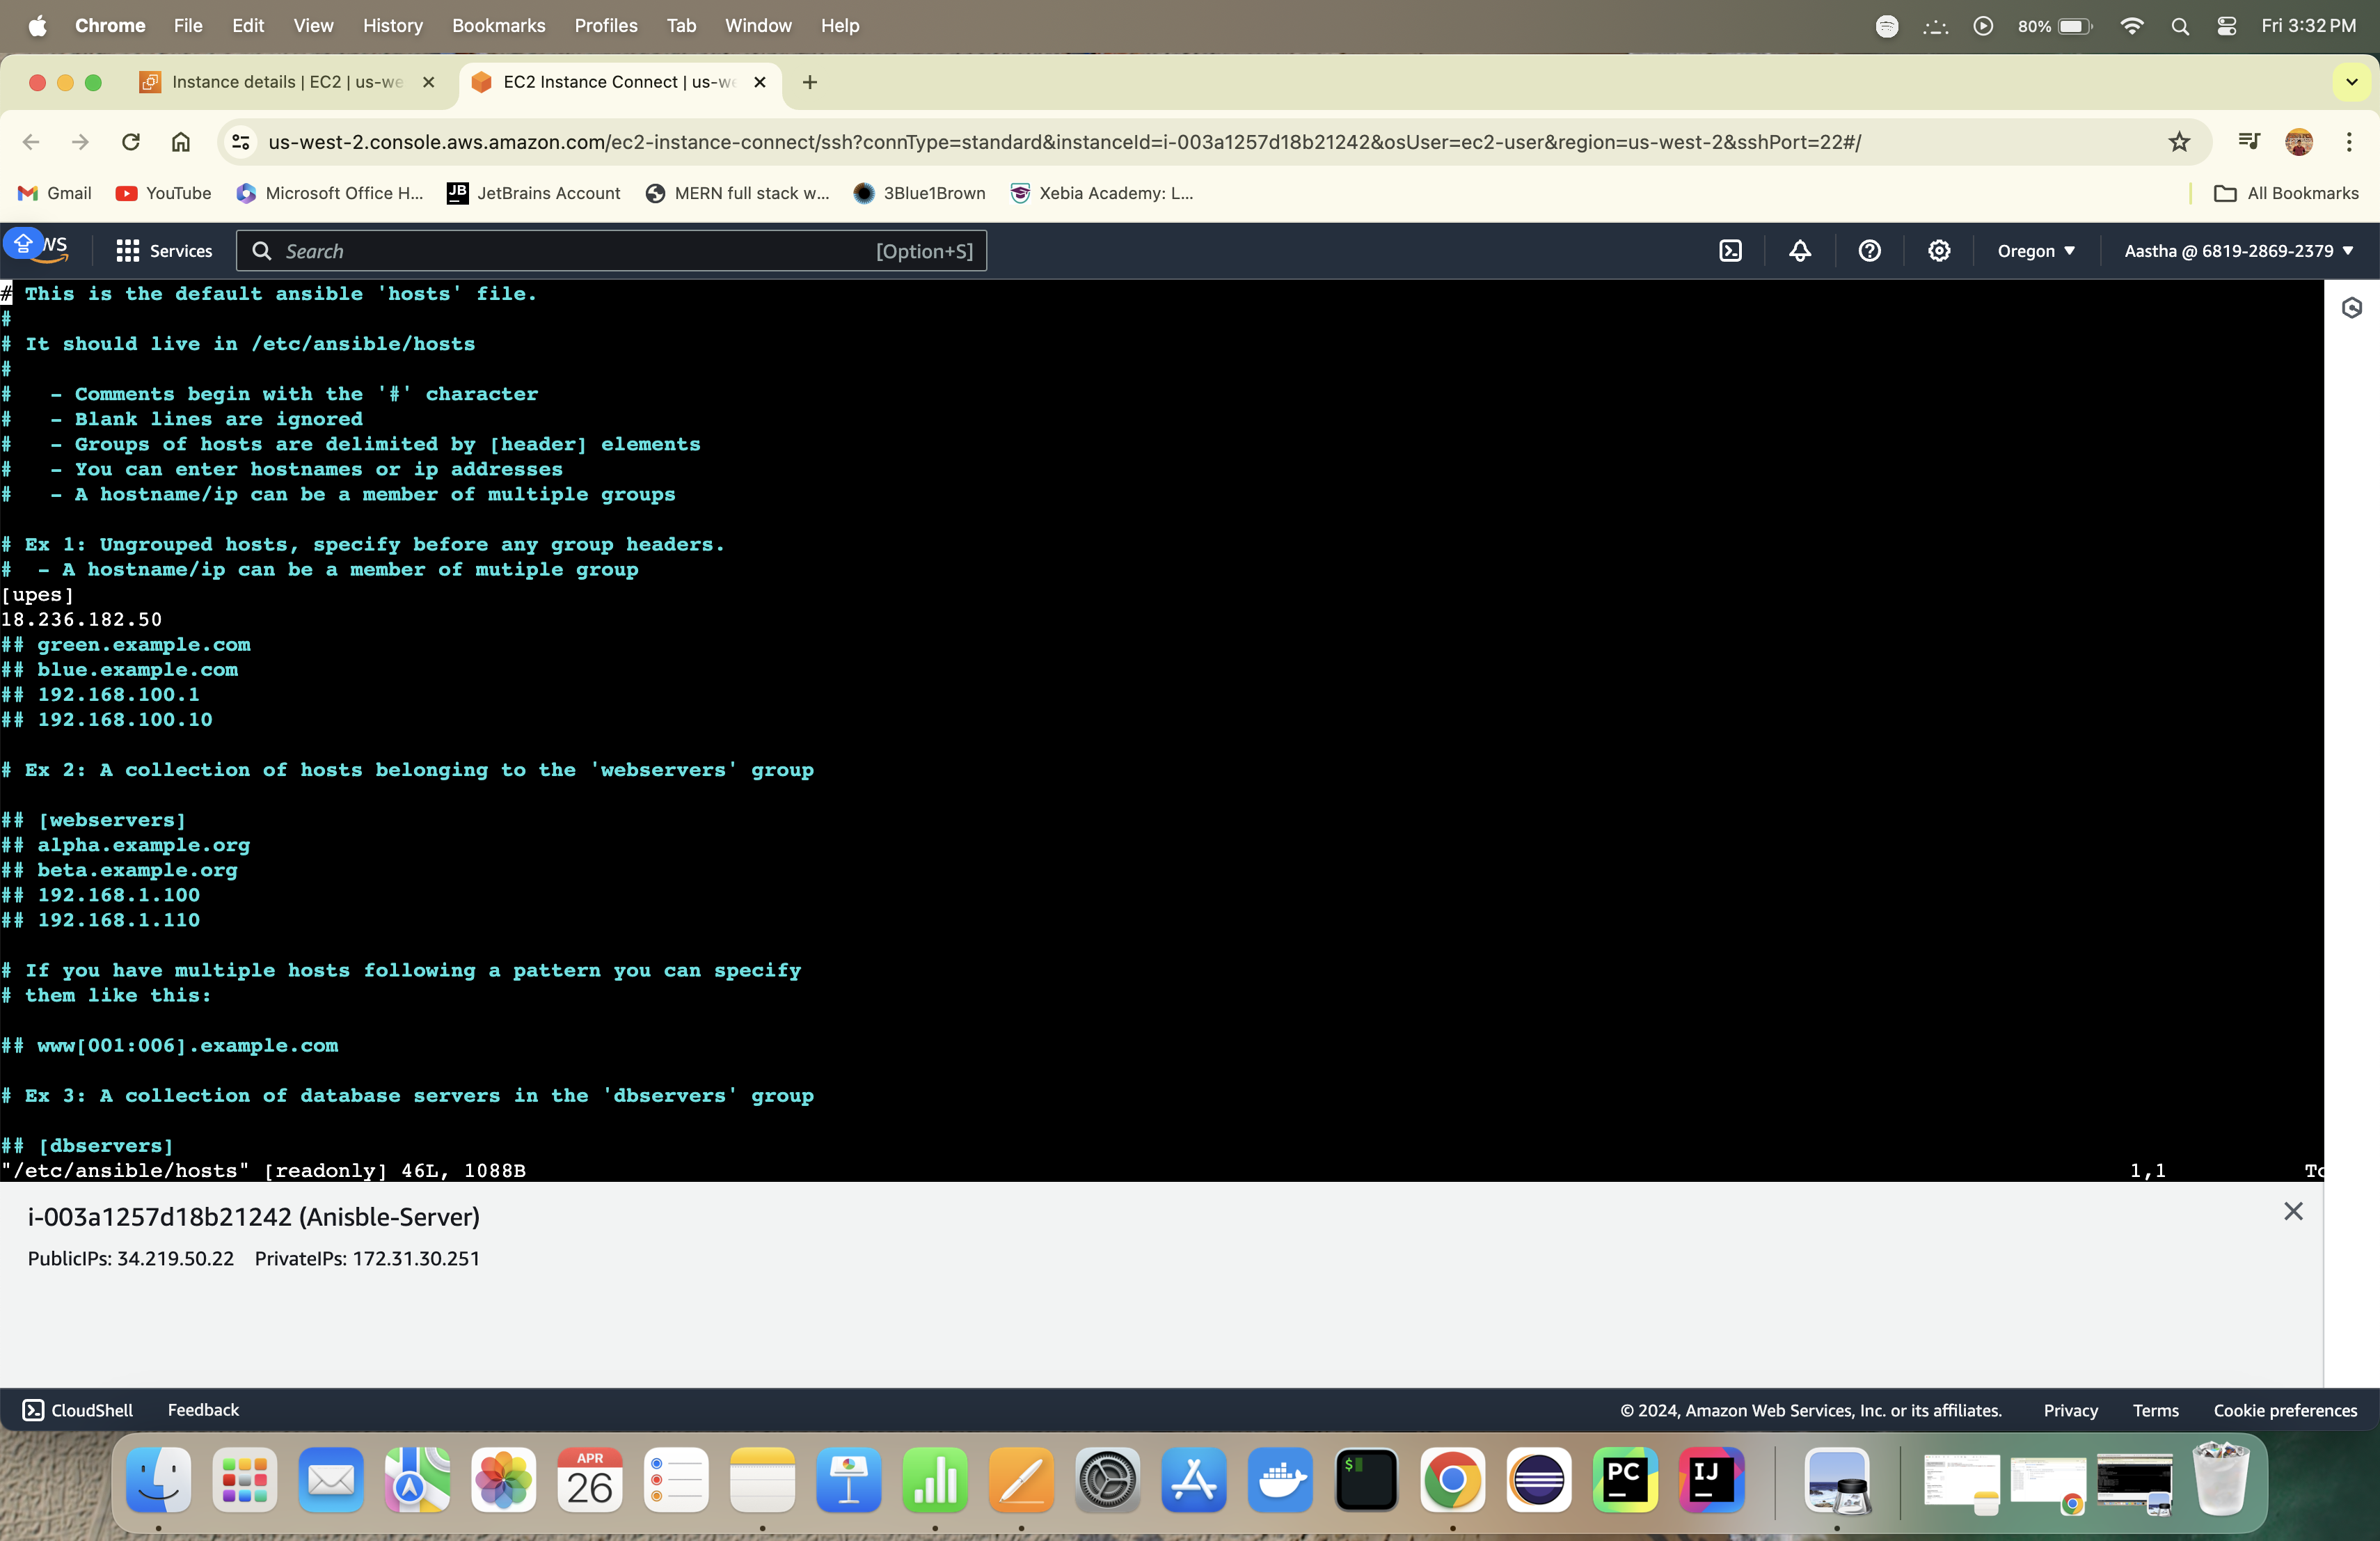

Step 4-: Create a ansible user and password and update the root permissions for both the users inside visudo file

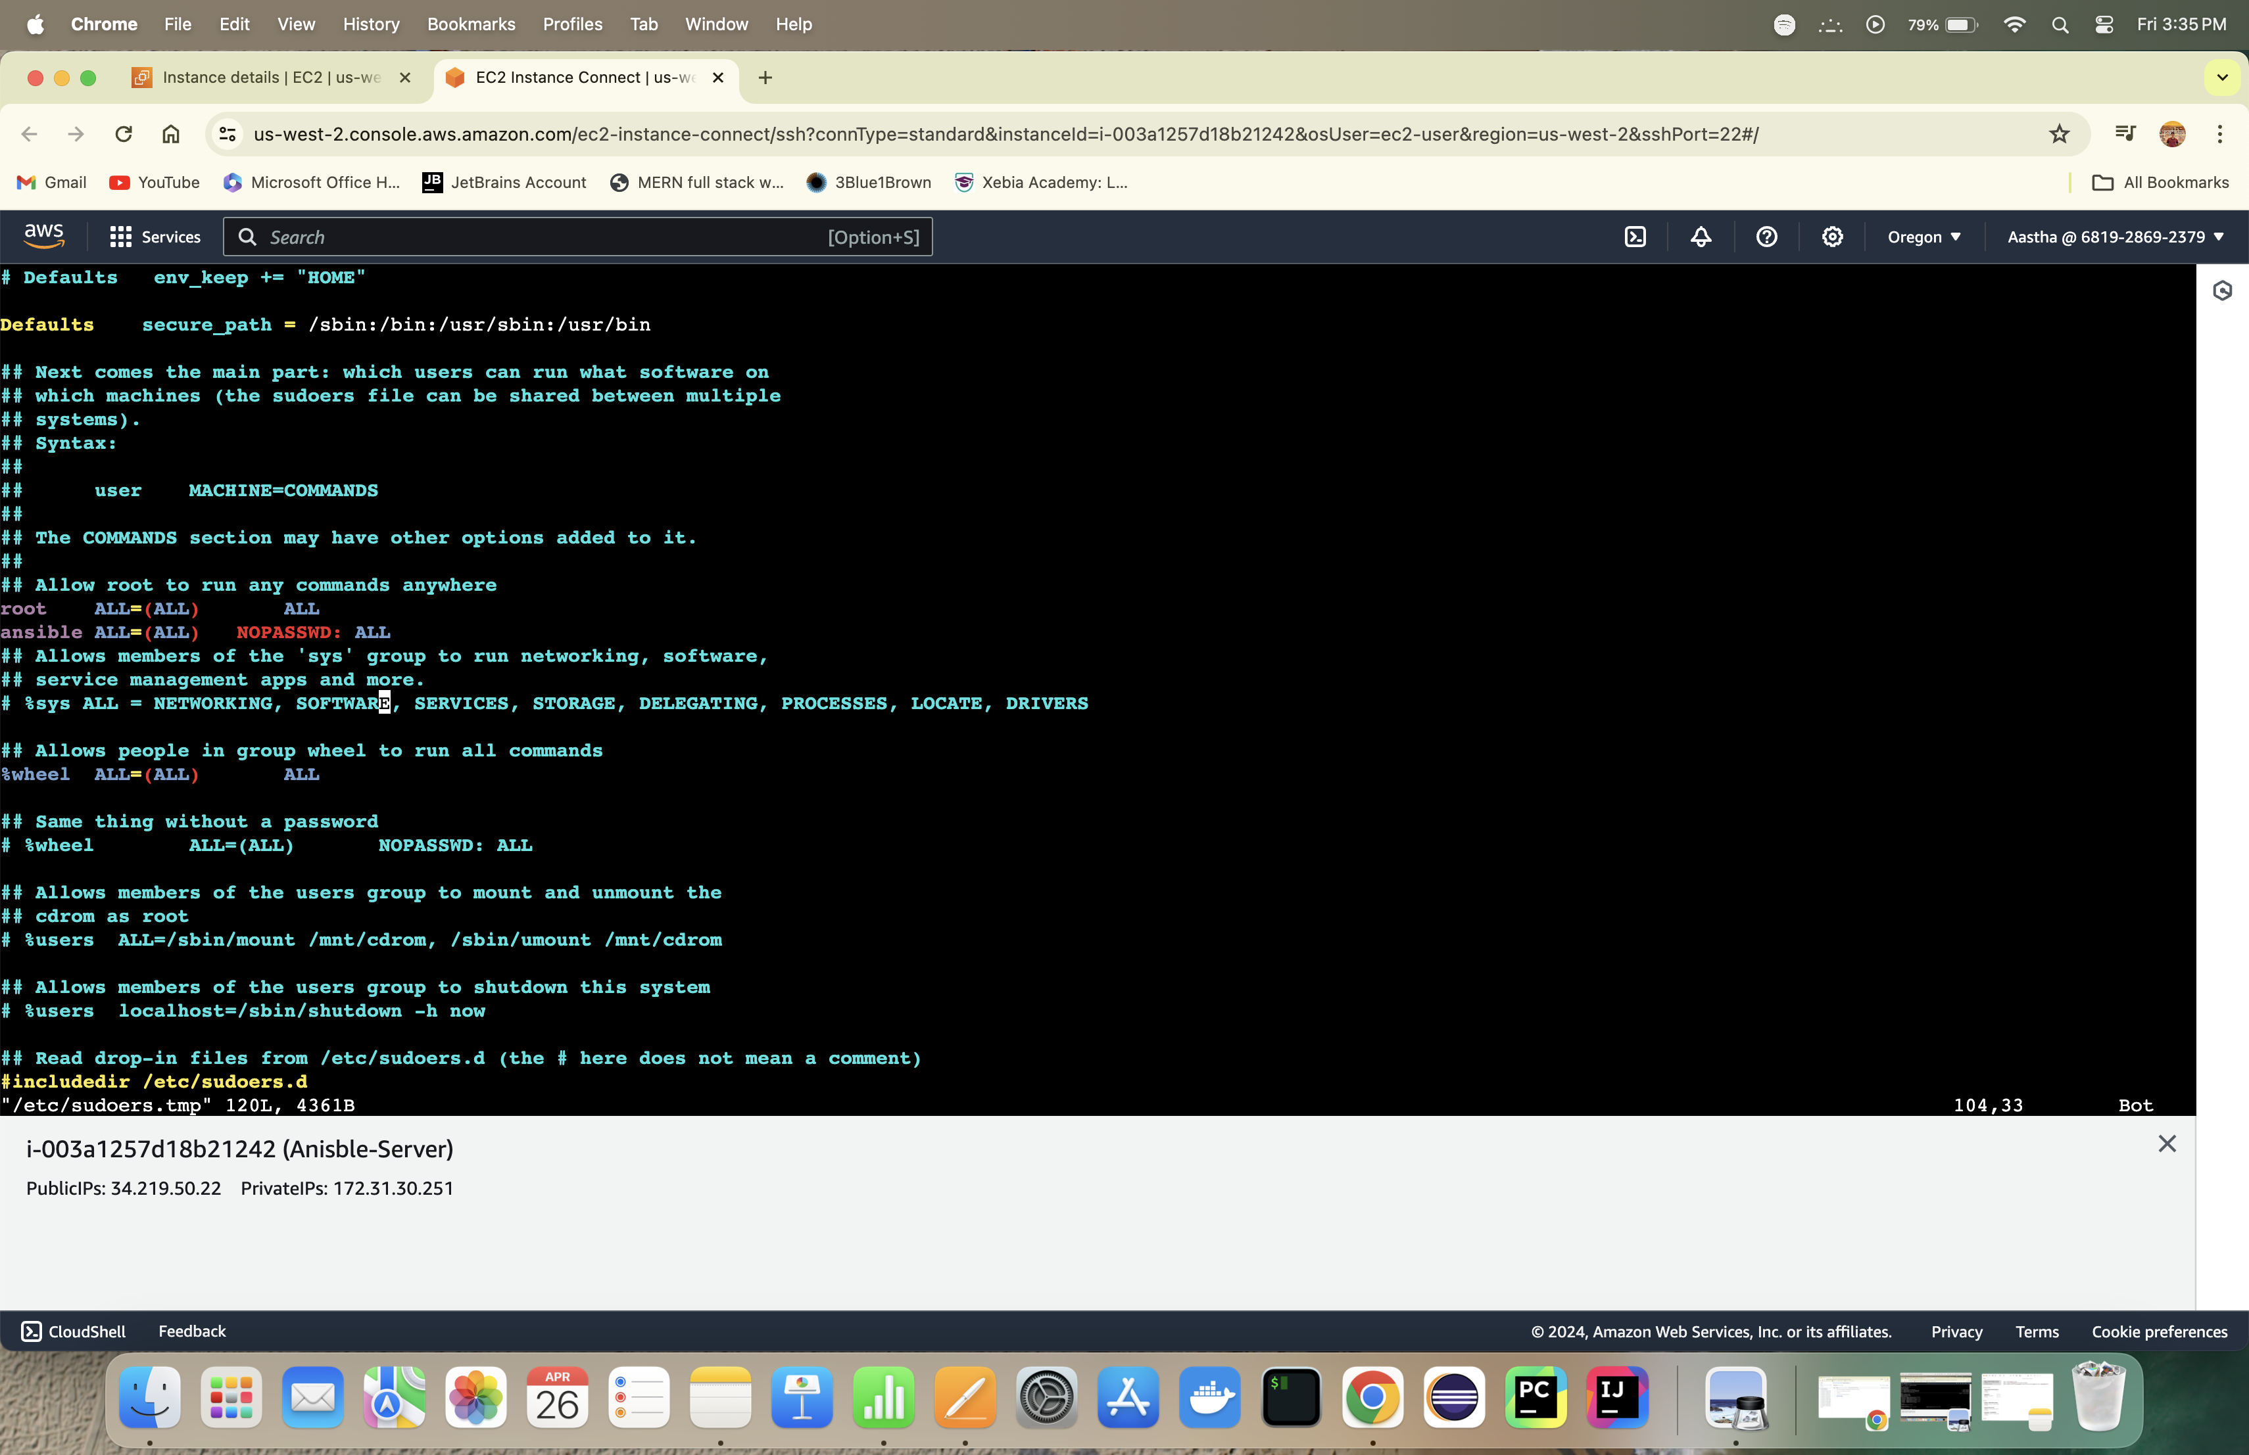

Step 5 Create a ssh key in ansible server

Step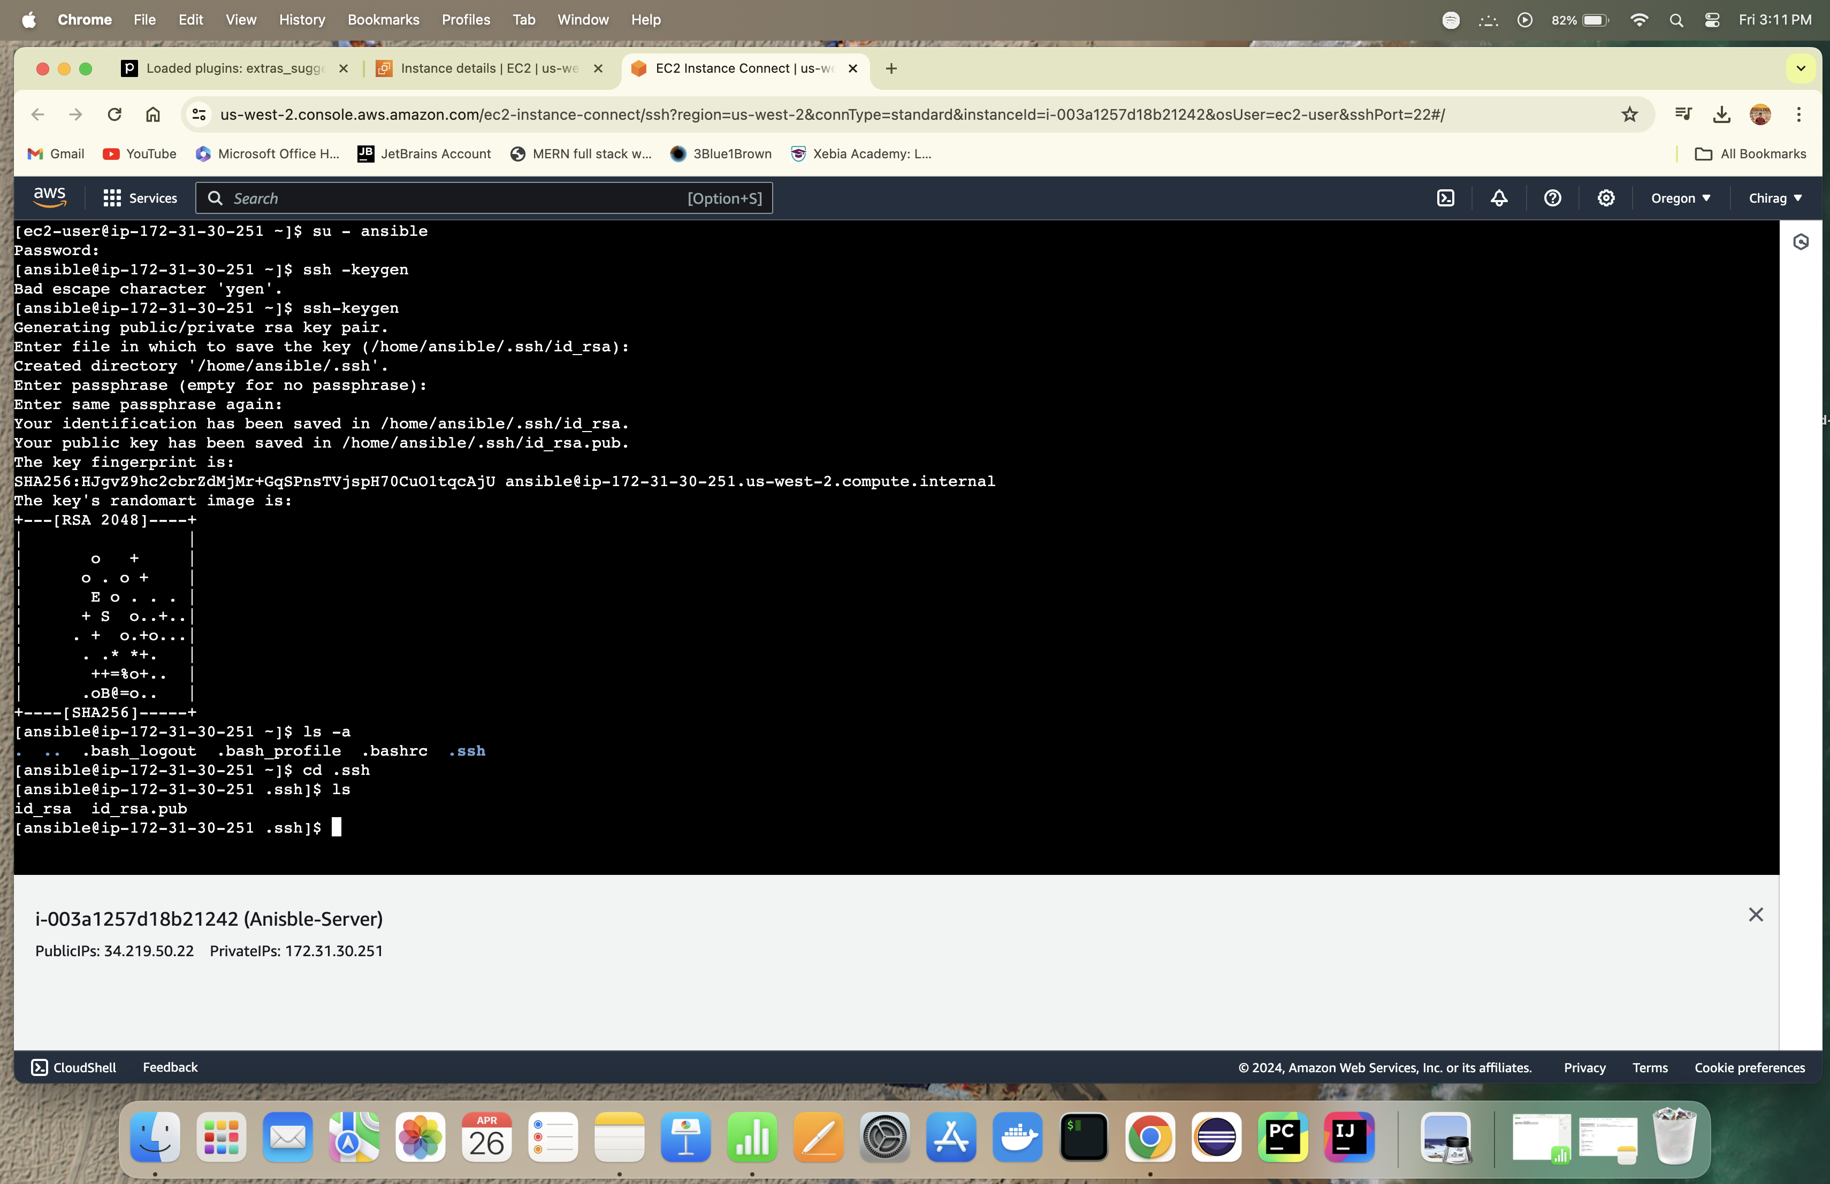 6: Copy the ssh key to connect with Ansible node

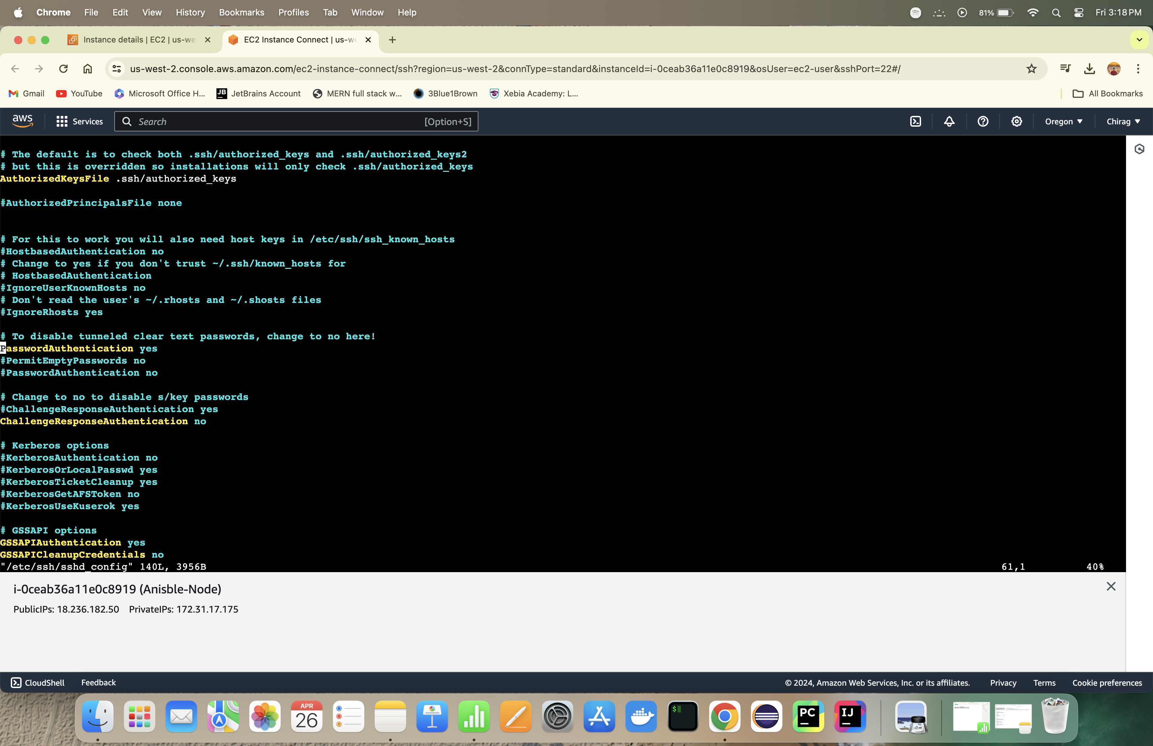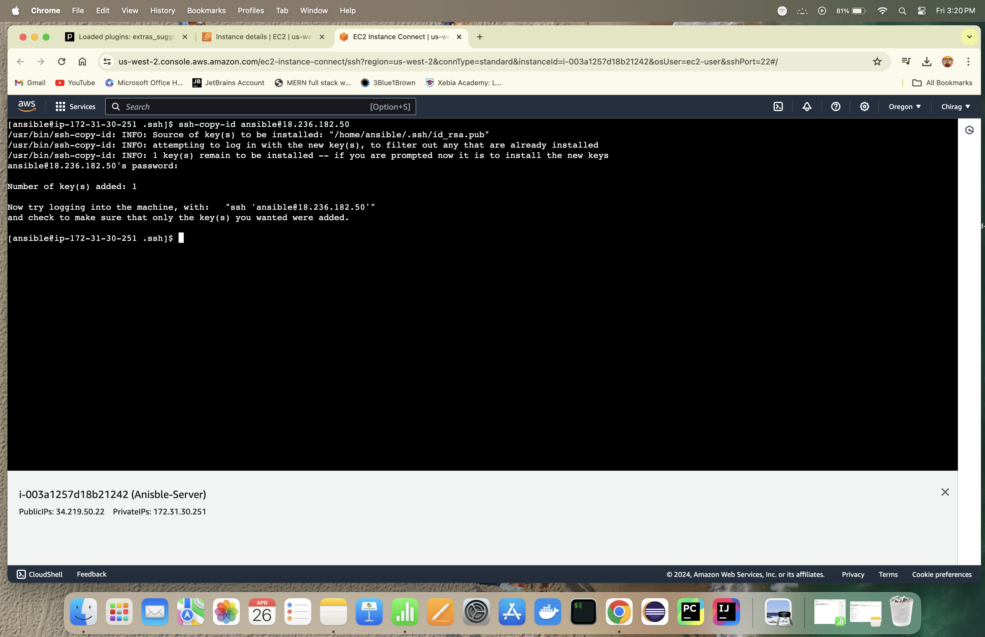

Step 7 -: Connect with Node instance from Server instance

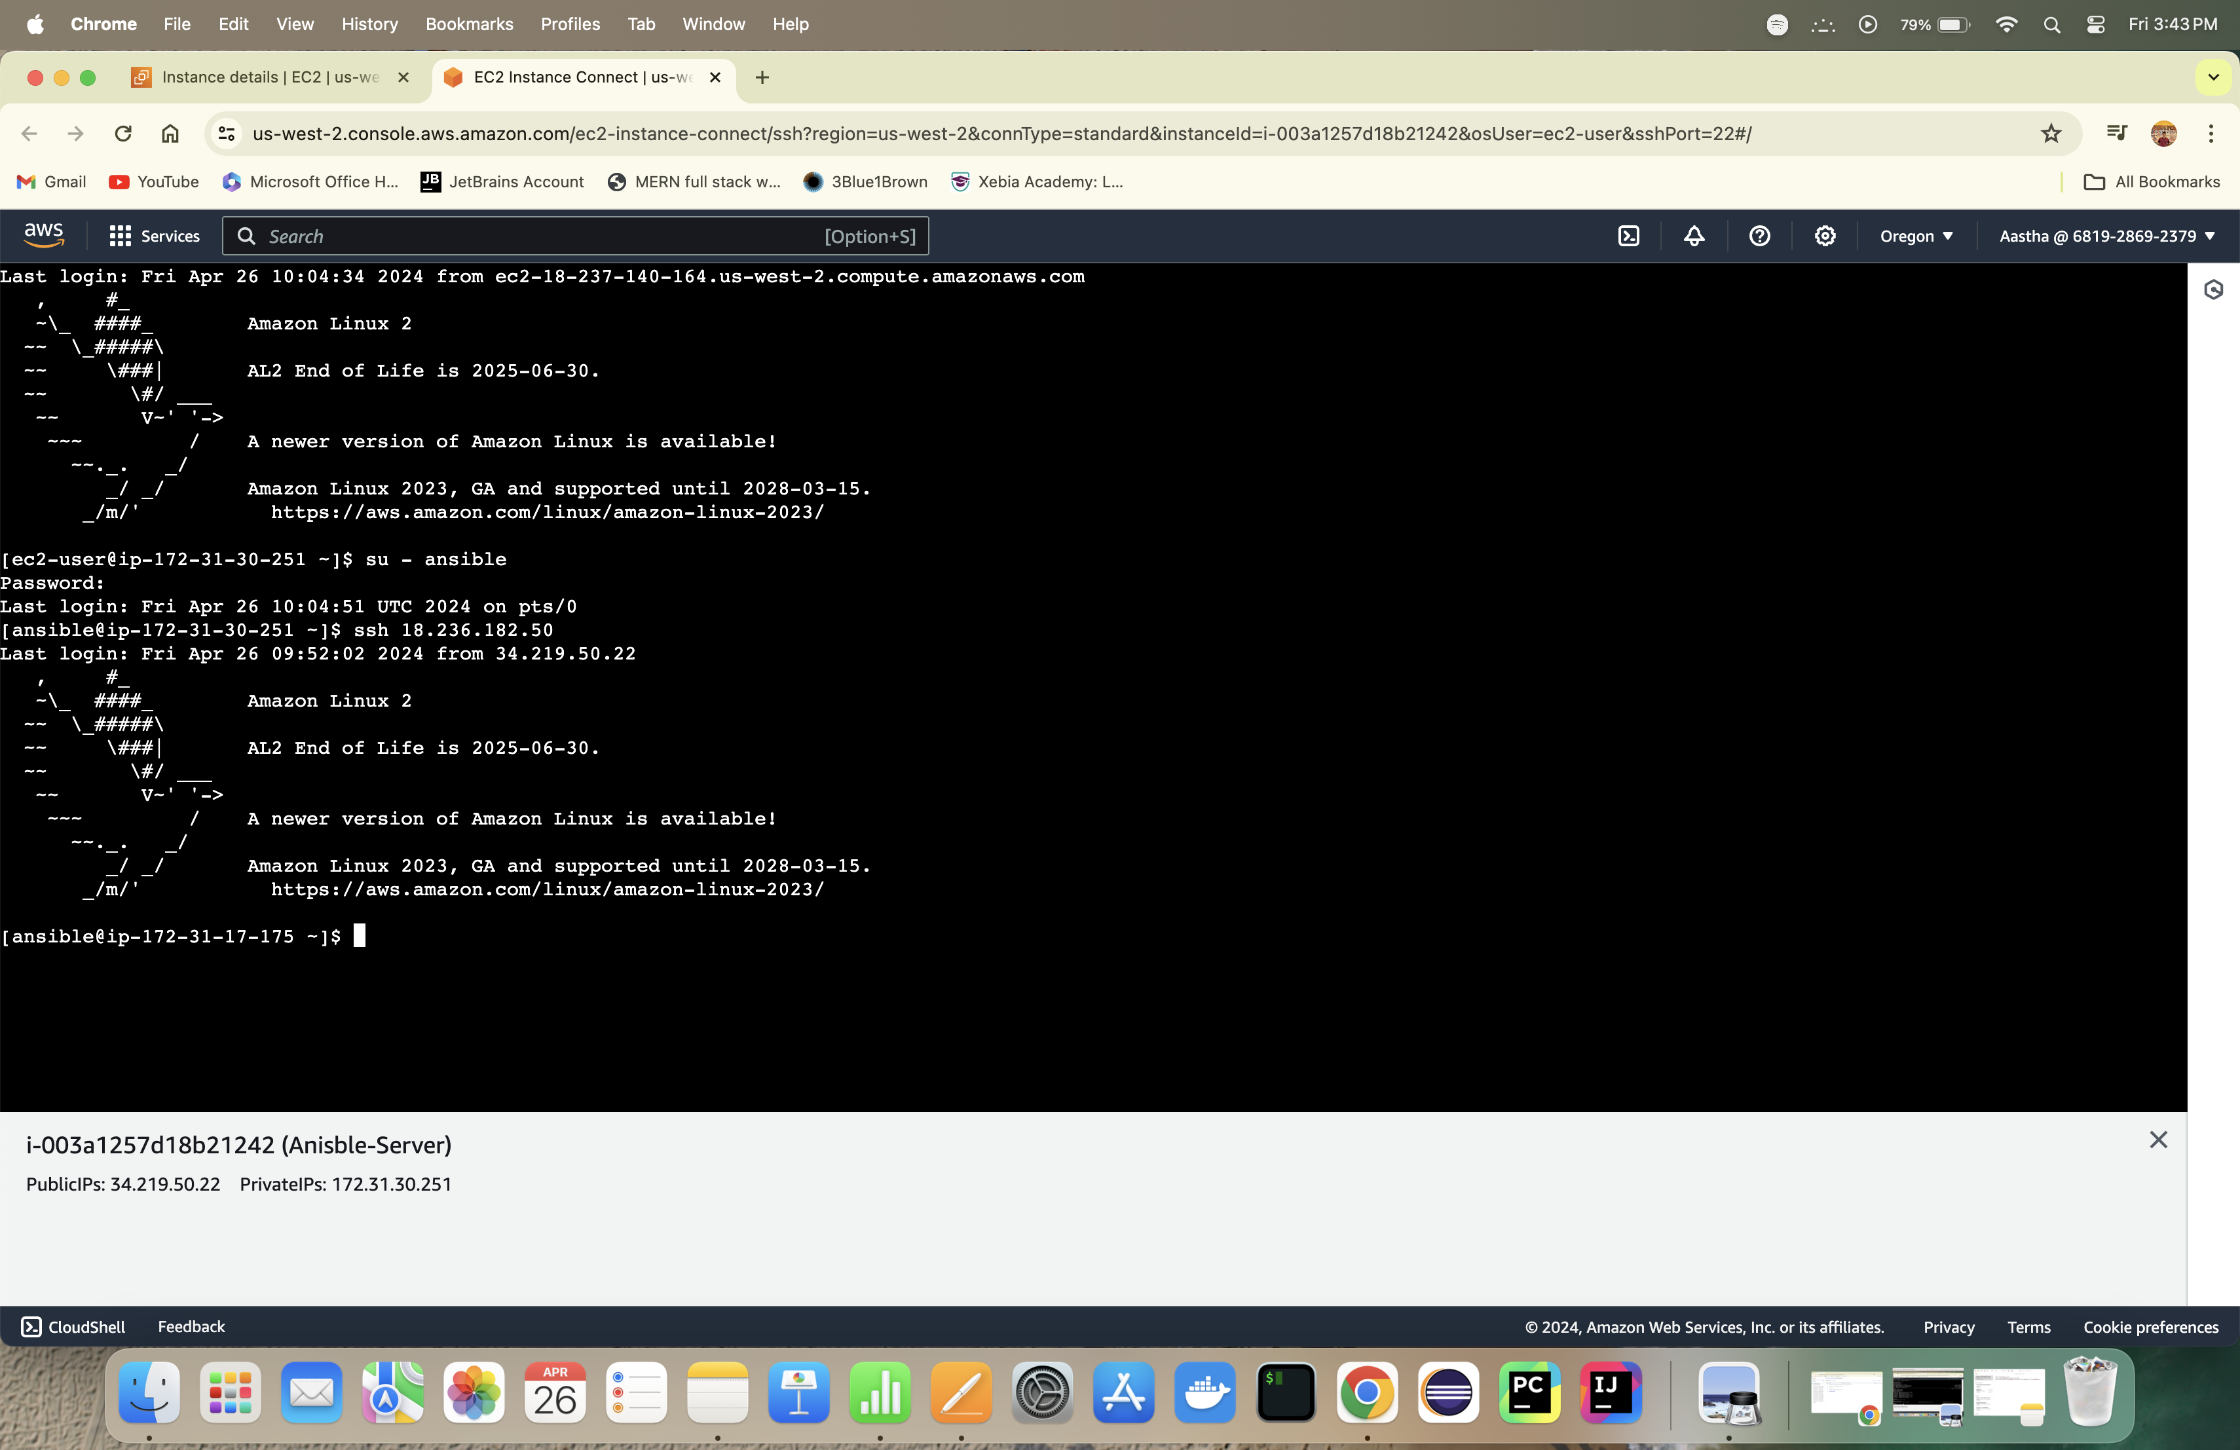

**EXPERMENT 12**

Step 1 -: Install httpd on ansible server inst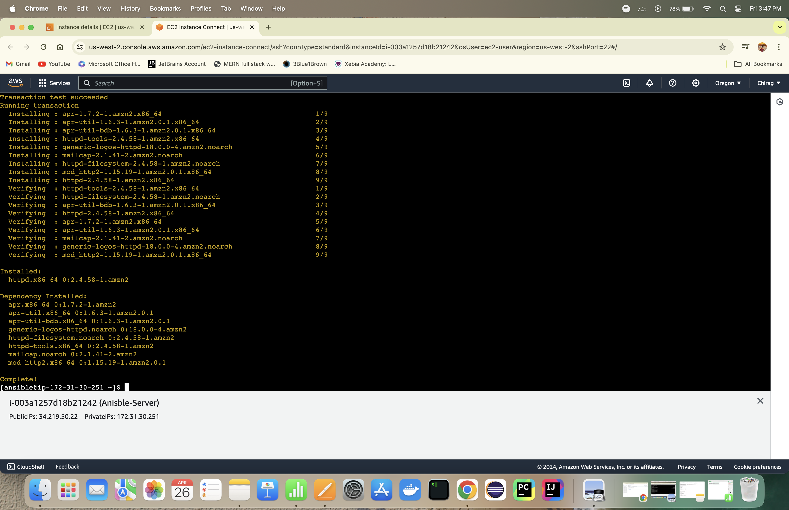ance

Step 2 -: Start the httpd service on node instance

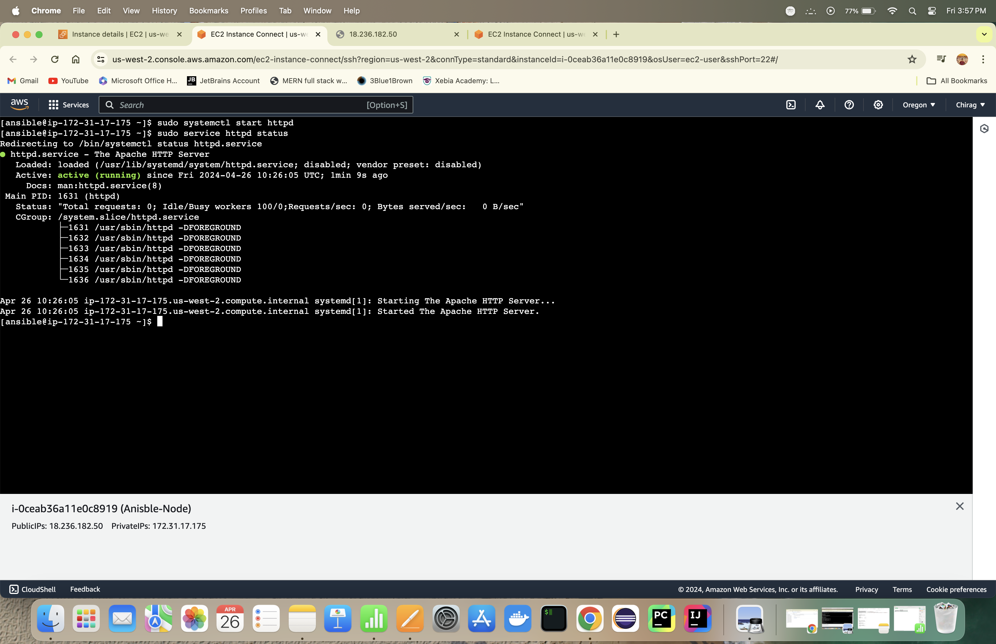

Step 3 -: Home Page can be seen on Node public IP

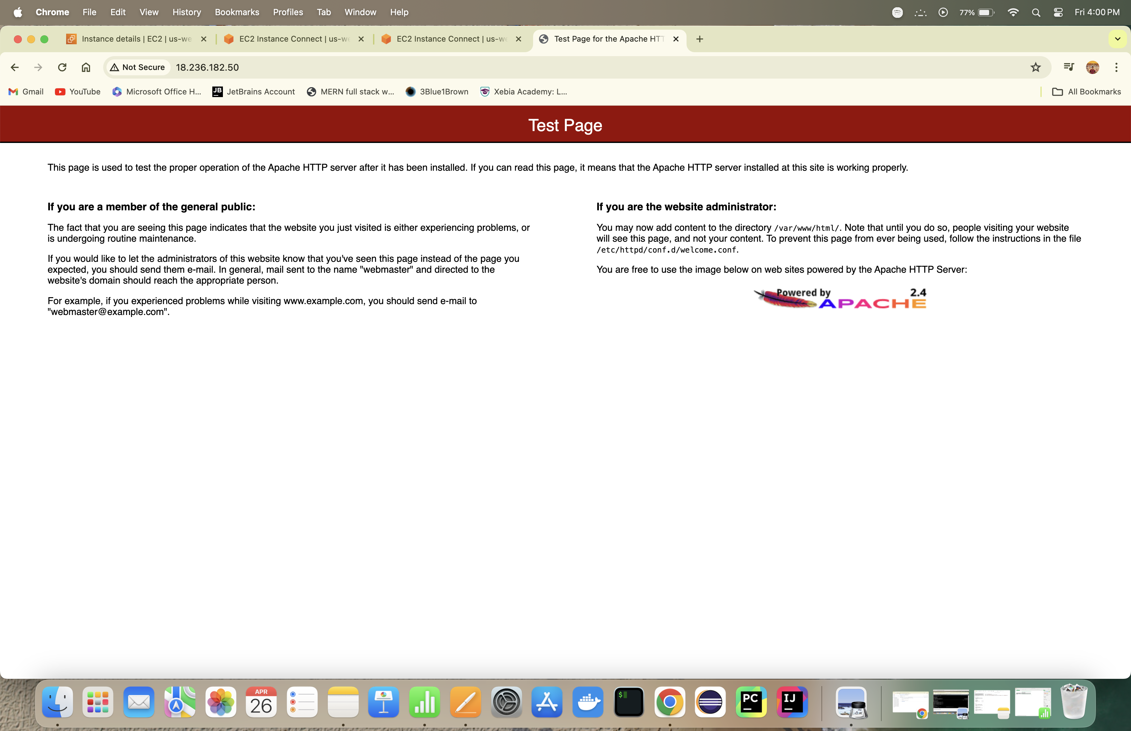

Step 4 -: Remove the httpd manually using command

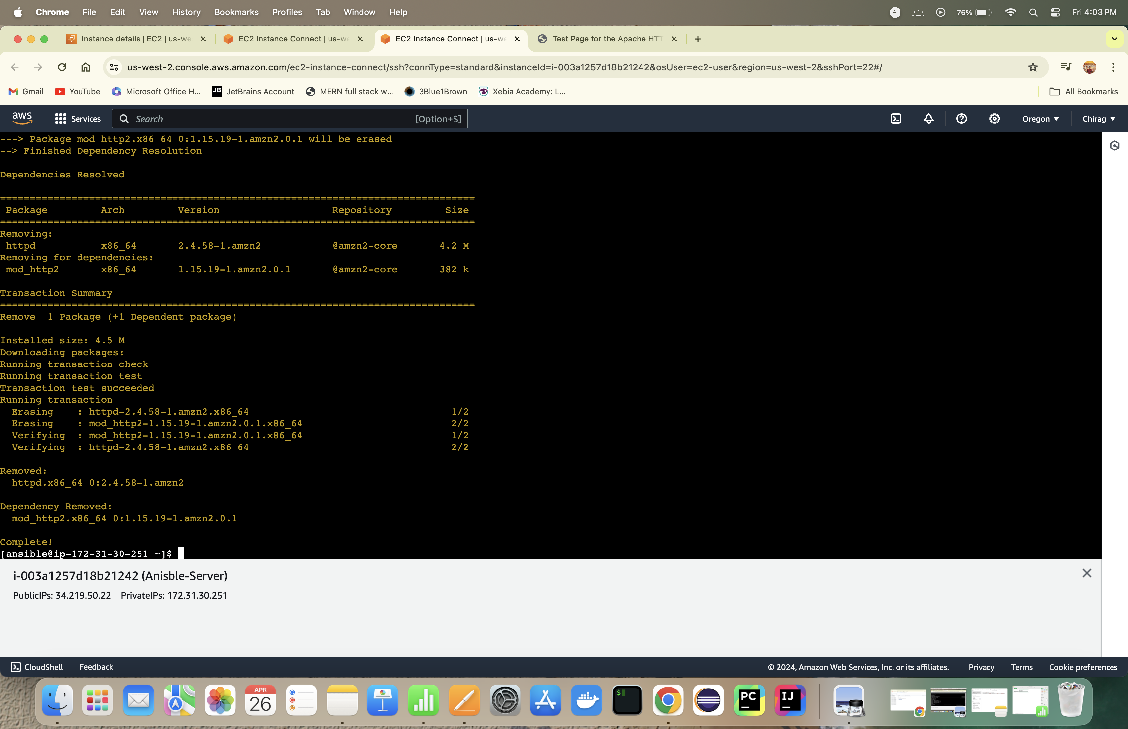

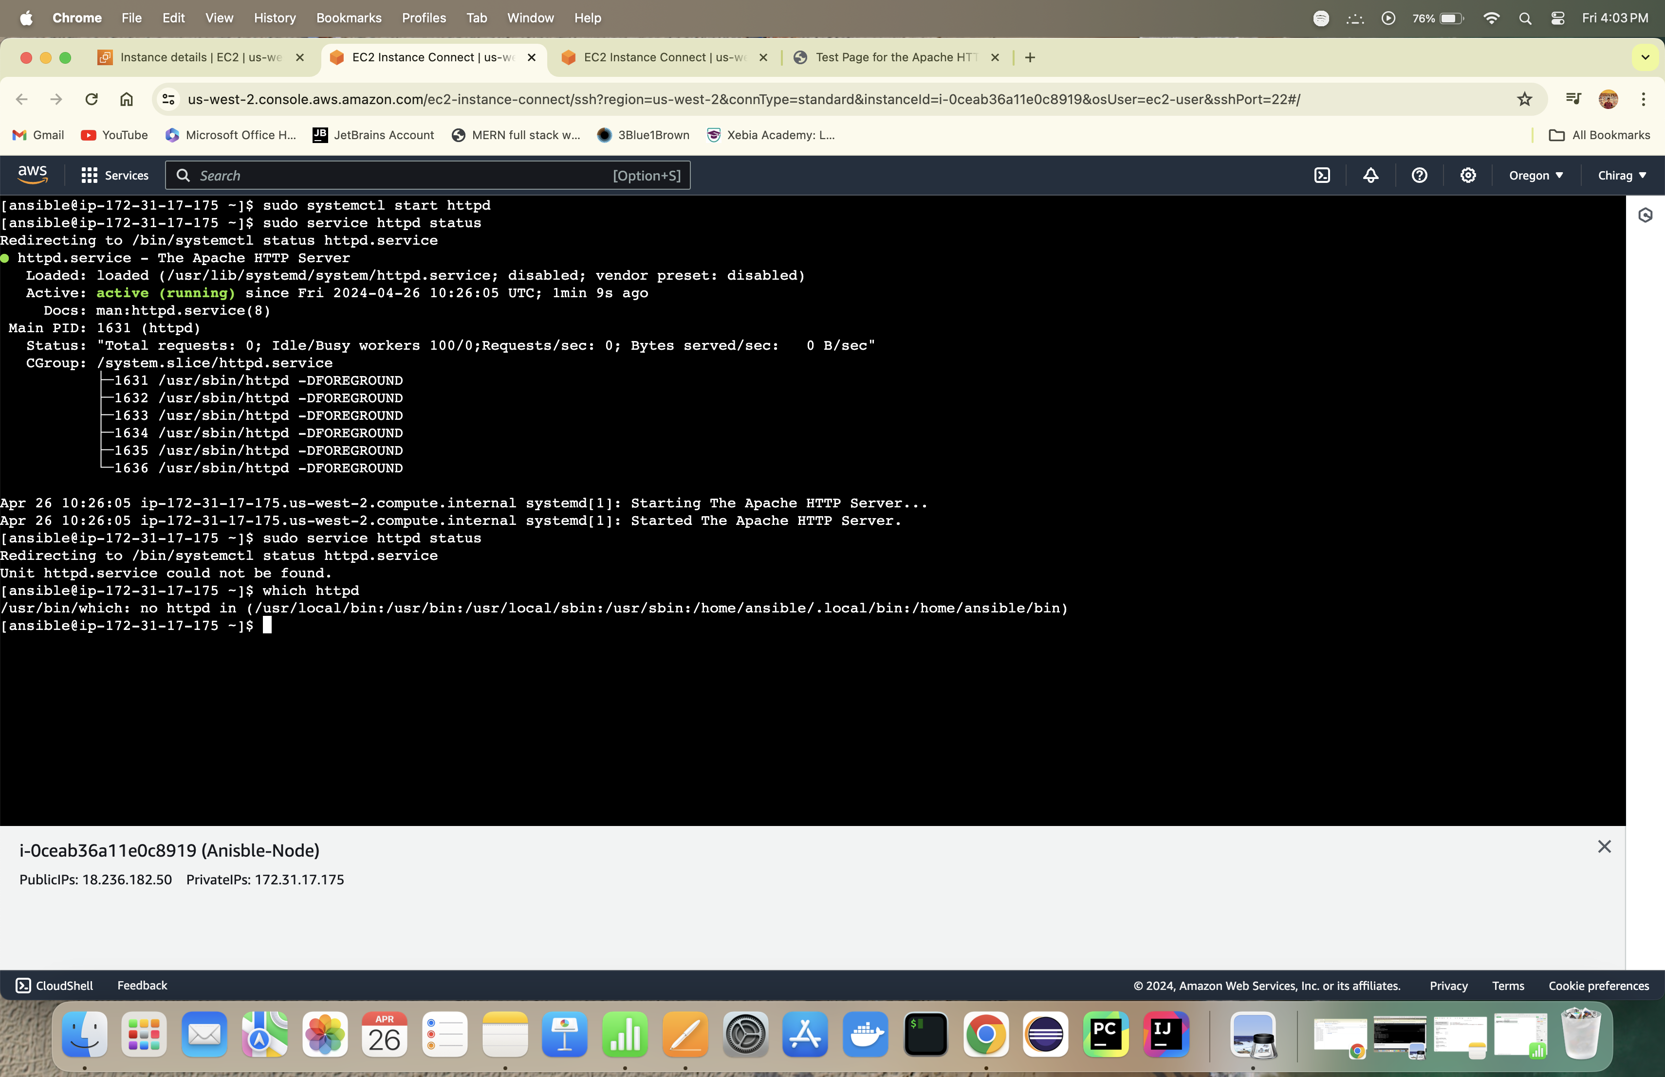

Step 5 -: Using all the task using playbook